APPENDIX U2
BINDER DRAINAGE TEST
[PS Clause 9.74]

Scope | U2.1 | This test determines the target binder content for a friction course material, to prevent excessive binder drainage occurring during manufacture, transportation and laying.  The quantity of binder lost through drainage, after a specified time at the maximum mixing temperature, shall be measured in duplicate for mixes with the same aggregate contents but with different binder contents. The target binder content shall be defined as the value 0.3 per cent less than that which 0.3 per cent binder drainage occurs, see also paragraph U2.7 below.
Apparatus | U2.2 | The apparatus shall consist of:-
 |  | (a) Balance of not less than 2kg capacity, accurate to 0.1 g.
 |  | (b) Oven, with fan-assisted air circulation, fitted with thermostatic control to maintain the temperature to ±3°C in the range of 80°C to 200°C and having sufficient internal volume to accommodate 10 drainage baskets and trays.
 |  | (c) Mechanical mixing unit of not more than 8 L capacity, capable of combining 1500g of aggregate, filler and binder speedily and thoroughly, without loss, as described in BS 598 : Part 107.
 |  | (d) Whisk, as described in BS 598 : Part 107.
 |  | (e) Drainage baskets, twelve in number, constructed from perforated metal with 3.1±0.1mm diameter holes and with 38±3 per cent open area, on sides and base to form 100±2mm cubes, with feet, at each corner of the base, of 3±0.5mm diameter and 5±1 mm height.
 |  | f) Spatula, with a blade approximately 150mm long by 25mm wide.
 |  | g) Metal trays, approximately 150mm square and 10mm deep, twelve in number.
 |  | h) Metal boxes, approximately 150mm by 150mm, thirteen in number.
 |  | i) Aluminium foil, of thickness 0.015±0.005mm.
Procedures | U2.3 | The procedure shall be follows:-
 |  | i) The test shall be carried out at the mixing temperature of 160±3°C or otherwise recommended by the Supplier and agreed by the Supervisor.
 |  | ii) Weigh thirteen batches of 1.1kg of combined aggregate, in the proportions for each fraction, to the nearest 1g to give a grading complying with the target grading. Place each batch in a separate tin.
 |  | iii) Pre-heat the oven to the mixing temperature and place the tins with aggregates in the oven for the least 3±1 hours prior to use.
 |  | iv) Pre-heat, stir and sub-divide the binder by the method stated in BS 598 : Part 107.
 |  | v) Wrap each tray with aluminium foil. Weigh each tray with foil to the nearest 0.1g (W1).
 |  | vi) Pre-heat the mixing unit to the mixing temperature for at least 1.5±0.5 hour prior to use.
 |  | vii) Transfer a 1.1kg batch of aggregate to the mixing bowl.
 |  | viii) When natural rubber powder is to be used, add the required quantity to the mixing bowl. Fit the mixing bowl to the mixer and fit the whisk. Dry mix for 30±3 s before adding the bitumen.
 |  | ix) Stir the heated binder in its container and weigh by difference the required amount of binder, to the nearest 0.5g, into the mixing bowl to give 3.0 per cent by mass in the unit.
 |  | x) When natural rubber latex is to be used; after adding the bitumen fit the mixing bowl to the mixer and fit the whisk. Mix the aggregates and bitumen for 60±6 s. Stir the latex well and add the required quantity evenly over the mix.
 |  | xi) Fit the mixing bowl to the mixer; fit the whisk and mix for another 60±6 s. Using the spatula, scrape around the top of the bowl and whisk and transfer the scraped material into the mix. Continue mixing for a further 60±6 s.
 |  | xii) Discard the first mix.
 |  | xiii) Repeat steps (vii) to (xi).
 |  | xiv) Transfer the material to a basket, ensuring that the mixer bowl and whisk are scarped thoroughly using the spatula. Carry out this operation as rapidly as possible to minimise heat losses.
 |  | xv) Place the basket with the mix on a pre-wrapped tray in the oven at the maximum mixing temperature for between 3 and 3.25 hours.
 |  | xvi) Remove the basket and tray from the oven. Remove the basket from the drainage tray. When the tray has cooled sufficiently, weigh the tray and aluminium foil to the nearest 0.1g(W2).
 |  | xvii) After placing the first mix in the oven, repeat the procedure in steps (xiii) to (xvi) for a duplicate sample at the same binder content.
 |  | xviii) Repeat the procedure in steps (xiii) to (xvii) four times, but increasing the binder content in step (vii) to 3.5, 4.0, 4.5, 5.0, 5.5 and 6.0 per cent by mass, respectively
 |  | xix) When a modifier other than natural rubber is used the procedure for incorporating the modifier shall be according to the manufacturer’s instructions.
 | U2.4 | For each mix, the retained binder (per cent), R, shall be calculated from
 |  | R% = 100B{1 -D/(B+F)}/(1100+B)
Where:
D is the mass of binder and filler drained {W2-W1} (g)
B is the initial mass of binder in the mix (g)
F is the initial mass of filler in the mix (g)
 | U2.5 | If, for any pair of mixes at the same binder content, the difference in retained binder per cent exceeds 0.5 per cent of binder, the procedure in paragraph U2.3 and calculation in paragraph U2.4, for the pair of mixes at the same binder content, shall be repeated.
Reporting of results | U2.6 | The mean retained binder shall be calculated for each binder content. The retained binder content shall be plotted against the initial mixed binder content, together with the line of equality where the retained binder equals the mixed binder content. A smooth curve shall be drawn through the plotted values and extrapolated to intercept the line of equality as in Figure U2.1. The critical binder content, the maximum mixed binder content and the maximum retained binder content shall be recorded.
Reporting of Results | U2.7 | (a) | From Figure U2.1, the mixed binder content (M) shall be determined where the binder drainage is 0.3 per cent (yz).
 |  | (b) | The target binder content shall be (M-0.3) per cent.
 |  | (c) | As a check, the abscissa, (xy), should also equal 0.3 per cent between the line of equality and the point on the drainage curve where the binder drainage is 0.3 per cent (yz).
Retained binder (percent)
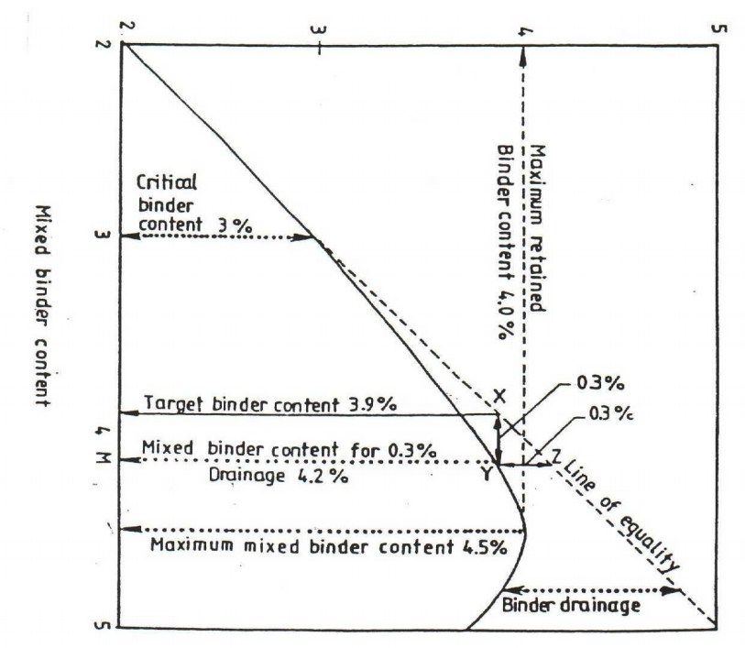
Figure U2.1

The “critical binder content” shall be the binder content at which the drainage curve deviates from the line of equality.
The “Maximum mixed binder content” shall be the mixed binder content at which the retained binder reaches a maximum value. If the retained binder does not peak, it shall be recorded as “greater than 6.0 per cent”.
The “maximum retained binder content” shall be the peak value that occurs at the maximum mixed binder content.
The “binder drainage” is the binder difference in per cent, between the mixed binder content and the retained binder content, at any particular mixed binder content point.

